Enhanced Biological Brain-Age Prediction via a Hybrid Crow Search Algorithm–LSTM Framework for Structural MRI-Based Neuroimaging
Jangam Subbarayudu*
Department of Computer Science and Engineering, SIMATS Engineering,
Saveetha Institute of Medical and Technical Sciences, Saveetha University,
Chennai, Tamil Nadu, India – 602105.
jsr5077@gmail.com
G. Michael
Department of Computational Data Science, SIMATS Engineering,
Saveetha Institute of Medical and Technical Sciences, Saveetha University,
Chennai, Tamil Nadu, India – 602105.
michaelg.sse@saveetha.com
V. Sheeja Kumari
Department of Computer Science and Engineering, SIMATS Engineering,
Saveetha Institute of Medical and Technical Sciences, Saveetha University,
Chennai, Tamil Nadu, India – 602105.
sheejakumari.sse@saveetha.com
*Corresponding author

Abstract
Biological brain-age estimation from neuroimaging has emerged as a leading candidate biomarker of neurological health, capturing cumulative structural aging that can diverge from chronological age. The gap between predicted and chronological age — the Brain-Predicted Age Difference (Brain-PAD) — is repeatedly associated with elevated risk of cognitive decline and neurodegenerative disease, yet high-dimensional structural feature spaces are prone to overfitting, and most pipelines that incorporate a sequential or recurrent component apply it to a single, undifferentiated feature stream rather than combining a metaheuristic-selected tabular representation with an independently learned structural-sequence representation of the same scan.
This paper proposes a hybrid framework that combines the Crow Search Algorithm (CSA), a population-based metaheuristic modeled on corvid caching behaviour, with a bidirectional Long Short-Term Memory (LSTM) network operating on a per-subject sequence of 2D slices extracted from the same structural (T1-weighted) volume. CSA performs global, non-linear search over the tabular structural feature space, scoring candidate subsets against a cross-validated accuracy–sparsity fitness function; a bidirectional LSTM, fed a per-slice CNN encoding of the volume's slice sequence with an attention-pooling layer, independently learns a structural-sequence embedding of the same scan. The CSA-selected tabular features pass through a compact 1D-CNN branch; its embedding is fused with the LSTM branch's embedding, and a shared multilayer-perceptron head predicts continuous chronological age from the fused representation, trained end-to-end.
A complete, end-to-end pipeline is described — multi-source harmonization, structural preprocessing, tabular feature extraction, CSA-based feature selection, slice-sequence extraction for the LSTM branch, dual-branch fusion, and training — together with ablation, interpretability (SHAP on the CSA-selected features; attention-weight visualization over slices), and robustness analyses (cross-source generalization, hyperparameter sensitivity, an external hold-out cohort). In the illustrative evaluation setting reported in this manuscript, the proposed hybrid CSA–LSTM model attained a development-pool cross-validated MAE of 2.42 ± 0.05 years, RMSE of 3.18 ± 0.05 years, and Pearson r of 0.931 ± 0.003, against an external hold-out MAE of 2.61 years and Pearson r of 0.919; CSA reduced the 142-dimensional tabular feature space by approximately 75.6% on average across folds. These figures are reported as illustrative, protocol-consistent values pending execution of the pipeline on a confirmed real dataset, and are clearly flagged as such wherever they appear in this manuscript (Section 3); they are not to be cited as measured findings.
Because CSA compresses the tabular feature space substantially before it reaches the model, and because the LSTM branch's attention weights indicate which slices contributed most to its embedding, predictions remain traceable to a specific, small feature subset and a specific spatial region of the volume rather than to an unexplained black box. The framework is deliberately scoped to structural MRI only, targeting freely accessible datasets (IXI, OASIS-1) that do not require a data-use application; extending it to true dynamic functional-connectivity (dFC) sequences from resting-state fMRI is identified as future work. The principal contribution of this work is a concrete, implementable, and reproducible dual-branch architecture and evaluation protocol for structural-MRI brain-age prediction, together with an explicit specification of the validation steps required before any clinical interpretation of its output is warranted.

Keywords
Brain age prediction; Crow Search Algorithm; LSTM networks; structural MRI; feature selection; slice-sequence modeling; explainable deep learning; neurodegenerative disease biomarkers

1. Introduction

1.1 Background and Motivation
The human brain undergoes continuous structural and functional reorganization across the lifespan, shaped by the joint action of genetic predisposition, environmental exposure, lifestyle, and epigenetic modification [1,2]. These processes manifest as progressive gray-matter atrophy in regions such as the hippocampus and prefrontal cortex, white-matter demyelination that reduces signal-transmission efficiency, altered synaptic plasticity, and large-scale functional network reconfiguration that partially compensates for structural loss [3]. Collectively, they motivate the concept of biological brain age: a physiologically grounded summary of cumulative neural aging that may diverge substantially from chronological age [4].
The discrepancy between predicted and chronological age, the Brain-Predicted Age Difference (Brain-PAD), is defined as:
Brain-PAD = Age_predicted − Age_chronological (1)
Positive Brain-PAD is repeatedly associated with elevated risk of cognitive decline, frailty, and neurodegenerative disease, including Alzheimer's disease, Parkinson's disease, and vascular dementia [5,6]. Longitudinal cohorts suggest that Brain-PAD increases of a few years can precede clinical dementia diagnosis, motivating its use as an early, non-invasive screening signal for at-risk individuals [3,7]. Realizing that promise, however, requires prediction models that are simultaneously accurate, generalizable across sites and scanners, and interpretable enough that a clinician can trust and act on an individual prediction — three requirements that existing approaches satisfy only partially.

1.2 Structural MRI as the Primary Data Source, and the Case for a Sequential Component
Magnetic Resonance Imaging (MRI) offers non-invasive, whole-brain characterization of structure [7,8]. Structural (T1-weighted) MRI — the modality this framework targets — quantifies volumetric and cortical-thickness changes in age-sensitive regions such as the hippocampus, entorhinal cortex, and temporal lobes [9], and is available from large, freely accessible repositories (IXI, OASIS-1) without the data-use applications that functional and multi-site clinical cohorts typically require. This accessibility is a deliberate scoping choice: it is what makes the framework something a lab without an existing data-sharing agreement can run and report genuine, reproducible numbers from.
The tabular volumetric/morphometric feature space derived from a single structural scan has no inherent ordering — a regional-volume vector is a set of measurements, not a sequence. This motivates pairing tabular structural features with a genuinely sequential representation of the same scan: a per-subject sequence of 2D slices through the 3D volume, encoded slice-by-slice and passed through a bidirectional LSTM. This is a more modest claim than modeling the moment-to-moment reconfiguration of dynamic functional connectivity (dFC) from resting-state fMRI, which requires functional data that this framework's target datasets do not include; Section 1.3.3 addresses that literature explicitly.

1.3 Related Work and Research Gaps

1.3.1 Deep Learning Advances in Brain-Age Prediction
Deep learning has substantially advanced brain-age prediction by learning non-linear structure directly from high-dimensional MRI data [13]. Cole et al.'s foundational 3D-CNN on UK Biobank T1-weighted scans established Brain-PAD as a heritable, clinically meaningful trait [1]. More recent work has pursued higher accuracy and richer modalities: DenseNet architectures applied to clinical 2D T1 scans [14]; deep-learning-based brain-age estimation for fetal MRI, used to flag cerebral ventriculomegaly [20]; and multimodal fusion of T1 and diffusion-tensor imaging with cognitive-performance correlations [15]. Despite this progress, three limitations recur across the literature: (i) persistent overfitting in feature spaces of 10³–10⁵ dimensions evaluated on heterogeneous, multi-site cohorts [16,17]; (ii) underuse of dFC's temporal structure beyond simple summary statistics [18,19]; and (iii) external-validation MAE inflation of up to approximately 20% relative to cross-validated performance, reflecting limited cross-scanner generalizability [20,21].

1.3.2 Metaheuristic Feature Selection in Neuroimaging
Classical dimensionality-reduction techniques — PCA, LASSO, recursive feature elimination — offer computational simplicity but limited capacity to capture non-linear, interacting feature relevance, and RFE in particular requires expensive iterative retraining. Bio-inspired metaheuristics such as Genetic Algorithms and Particle Swarm Optimization achieve comparable sparsity with less retraining overhead, but none carry any explicit notion of time. The Crow Search Algorithm (CSA) [37], modeled on the caching and cache-protecting behavior of corvids, has shown strong global-search performance on medical feature-selection tasks: hybrid CSA variants for medical diagnosis [22], CSA-based feature extraction for Alzheimer's disease diagnosis [14], chaos-augmented CSA variants with improved convergence over genetic algorithms [23], and dynamic awareness-probability adjustment strategies for high-dimensional classification [24,25]. None of these CSA applications, however, have previously been paired with an explicitly temporal model of neuroimaging dynamics — the gap this framework addresses.

1.3.3 Recurrent Modeling in Neuroimaging: Precedent and Scope of This Work
The strongest existing precedent for recurrent architectures in brain-age-adjacent neuroimaging comes from work explicitly modeling dFC as a sequence: interpretable time-attention LSTMs have been used to characterize spatio-temporal patterns predictive of disease progression in mild cognitive impairment [10,26,27], ICA-LSTM architectures have decoded spatio-temporal features linking dFC variance to symptom severity in Alzheimer's disease and autism spectrum disorder [26], and LSTM-graph hybrids have been proposed for non-stationary connectomes in aging, with explicit caution about overfitting risk [11]. More recent clinical translations include dFC-based Brain-PAD models in schizophrenia-related cognitive deficit [28]. This literature motivates the use of a recurrent component at all, but it is not the method this framework implements: without resting-state fMRI, there is no dFC sequence to model. What this framework does instead is apply the same architectural insight — that a bidirectional LSTM with attention pooling can extract age-relevant structure from an ordered sequence — to a sequence of 2D slices through a single structural volume, fused with, rather than into, a separately-selected tabular feature representation. This is explicitly a narrower, more modest claim than dFC sequence modeling (Section 5).

1.3.4 Positioning Against Existing Approaches
Table 1 summarizes how the proposed framework relates to the two families of methods it draws from and departs from.
Table 1. Positioning of the proposed CSA–LSTM framework relative to existing approaches.
Method family | Global / nonlinear search | Sequential / recurrent component | Feature-level interpretability | Retraining cost
PCA / LASSO | Limited (linear) | No | Moderate (linear weights) | Low
Recursive Feature Elimination | Model-dependent | No | Moderate | High (iterative)
GA / PSO metaheuristics | Yes | No | Low–moderate | Moderate
3D-CNN / Vision Transformer on raw volumes | Yes (implicit) | No (static input) | Low (post-hoc only) | High
LSTM-only dFC models (functional MRI required) | No | Yes (true temporal dFC) | Low | Moderate
Proposed CSA + slice-sequence LSTM fusion (structural MRI only) | Yes (CSA) | Yes (slice-sequence, not dFC) | High (SHAP on CSA-selected features; attention weights over slices) | Moderate
The fully end-to-end 3D-CNN/Vision Transformer family and the metaheuristic feature-selection family address only one side of a trade-off between accuracy/expressiveness and interpretability/efficiency; dFC-based LSTM models add genuine temporal modeling but require functional MRI. The contribution positioned as novel here is independently combining a metaheuristic-selected tabular structural representation with a learned slice-sequence representation of the same structural scan, fused at the embedding level for joint prediction, and evaluated with the rigor (ablations, significance testing, external hold-out) a fully multimodal pipeline would require.

1.4 Novelty and Key Contributions
Building on the gap analysis above, this work makes four contributions:
1. A dual-branch CSA-selected-tabular + slice-sequence-LSTM fusion architecture for structural MRI. CSA performs global, non-linear feature-subset search over the tabular structural feature space, independently of a bidirectional, attention-pooled LSTM that encodes a per-subject sequence of 2D slices through the same T1 volume (Section 2.5). The two branches' embeddings, not their independent selection decisions, are fused for joint end-to-end prediction.
2. An end-to-end, reproducible structural-MRI pipeline spanning multi-source harmonization, structural preprocessing, tabular feature extraction, CSA-based feature selection, slice-sequence extraction for the LSTM branch, the dual-branch fusion model, and training, specified in enough implementation detail (Section 2, Algorithm 1) to be independently re-implemented and run against freely accessible data (IXI, OASIS-1) without a data-use application.
3. Built-in interpretability on both branches: SHAP attributions over the CSA-selected tabular feature subset identify which structural measurements drive predictions, while the LSTM branch's attention weights over slices identify which regions of the volume the sequential branch weighted most heavily.
4. A candid robustness and generalization analysis — ablations isolating the CSA-tabular-only and LSTM-sequence-only contributions, cross-source and hyperparameter sensitivity checks, and a genuinely held-out external cohort — reported alongside, not instead of, the headline cross-validated metrics.

2. Materials and Methods

2.1 Dataset Assembly and Ethical Compliance
This framework targets structural (T1-weighted) MRI from sources that do not require a formal data-use application. Two concrete options are specified: (a) the Hugging Face radiata-ai/brain-structure release, a harmonized combination of IXI, OASIS-1, OASIS-2, DLBS, and NKI-RS (3,794 scans from 2,607 individuals, already skull-stripped and MNI-aligned); or (b) a single raw source organized directly — IXI (approximately 600 healthy subjects, ages 20–86) or OASIS-1 (416 subjects aged 18–96, including 100 with documented very-mild-to-moderate Alzheimer's disease, via CDR score). Each source carries its own citation and usage-terms obligations (see Data Availability), which must be honored regardless of which is used.
If multiple sources with different acquisition protocols are combined, site/protocol harmonization (e.g., ComBat [30]) becomes necessary to avoid inflated external-validation error from unaddressed scanner variance [20]. This is flagged as a required addition before combining multiple raw sources, and is not assumed to already be implemented.

2.2 Structural MRI Preprocessing
Each T1-weighted volume is processed with four steps, implemented with an honest fallback where the gold-standard tool is not installed (each fallback is logged rather than silently substituted):
1. N4 bias-field correction via ANTsPy [29] where available; otherwise a coarse low-frequency intensity-flattening fallback (Gaussian-smoothed field division).
2. Skull stripping via an Otsu-threshold-plus-largest-connected-component brain mask, with SynthStrip or HD-BET recommended for publication-grade masks.
3. Registration to MNI152 space via nilearn's template resampling where available, with a documented fallback to a fixed voxel-grid resample if that step fails.
4. Intensity normalization: z-scoring within the brain mask,
T_norm = (T_raw − μ_brain) / σ_brain (2)
applied uniformly regardless of source. Every subject's preprocessing outcome (success/failure, output shape) is logged to a per-run CSV, making preprocessing failures auditable rather than silently dropped.

2.3 Tabular Feature Extraction
Regional volumes and mean intensities are extracted using the Harvard-Oxford cortical and subcortical probabilistic atlases (thr25, 1 mm, via nilearn):
V_region^(i) = |{voxels ∈ region i}|, I_mean^(i) = mean(T_norm[voxels ∈ region i]) (3)
Whole-brain summary features (total brain volume, mean intensity, intensity standard deviation) are appended to the per-region features. The realized tabular feature dimensionality (typically on the order of 120–150 features) is written to a feature manifest and reported exactly once the pipeline is run rather than assumed in advance. This tabular feature vector is the direct input to the CSA feature-selection stage (Section 2.5.1).

2.4 Slice-Sequence Extraction for the LSTM Branch
Independently of the tabular stream, each preprocessed volume is resampled to a fixed number of axial slices (n = 32 by default) at a fixed 2D grid resolution (32×32 by default), giving each subject an ordered tensor:
S = [s1, s2, …, sn], s_k = zoom(T_norm[:,:,z_k], grid/H, grid/W) (4)
with slice indices z_k evenly spaced along the axial axis. This gives the LSTM branch a genuine ordering to model — anatomical continuity from slice to slice — without presenting it as a proxy for functional connectivity dynamics: this is a spatial sequence through one static structural scan, not a temporal sequence of brain states over time. A genuine dynamic functional connectivity (dFC) branch, feeding the same LSTM module a functional-temporal signal instead, is a natural extension if functional MRI access is obtained (Section 5).

2.5 Hybrid CSA + Slice-Sequence-LSTM Fusion Architecture
CSA and the LSTM branch operate independently on two different representations of the same structural scan — CSA selects a subset of the tabular ROI feature vector; the LSTM encodes the slice-sequence tensor — and only their resulting embeddings, not any shared importance score, are combined for prediction.

2.5.1 Crow Search Algorithm Component (Tabular Feature Selection)
CSA [37] models each candidate feature subset as the position of a 'crow' in binary feature space, updated using a memorized best-known position and an awareness probability that governs exploration versus exploitation. Each crow's position x_i ∈ [0,1]^d is initialized randomly and, each iteration, either follows a randomly chosen peer crow j's memorized best position or reinitializes at random:
x_i^(t+1) = x_i^(t) + fl·r·(m_j^(t) − x_i^(t)) if r ≥ AP; x_i^(t+1) ~ U[0,1]^d otherwise (5)
with flight-length fl and awareness probability AP as tunable hyperparameters (default fl = 2.0, AP = 0.1; population 30 crows, 40 iterations). The continuous position is mapped to a binary selection mask via a sigmoid-then-threshold transform:
mask_i = 1[ σ(4·(x_i − 0.5)) ≥ 0.5 ] (6)
and each candidate mask is scored with a fitness function that trains a fast surrogate regressor (Ridge regression, α = 1.0) under 3-fold cross-validation on the selected tabular feature subset, penalized for subset size to encourage sparsity:
F(mask) = MAE_3-fold(Ridge; X[:,mask], y) + λ_sparse·(‖mask‖₀ / d), λ_sparse = 0.002 (7)
A crow updates its memory only when a new position improves on its own best-known fitness; the population's best mask after the final iteration is the CSA output. CSA is re-fit independently within each cross-validation fold's training partition only (Section 2.7), never on validation or hold-out data, to avoid feature-selection leakage.

2.5.2 LSTM Slice-Sequence Component
Independently of CSA, a bidirectional LSTM encodes each subject's ordered slice-sequence tensor. Each slice first passes through a small per-slice 2D CNN encoder (three Conv2D+ReLU+MaxPool blocks, channels 16→32→64, global average pooling, linear projection to a 64-dimensional slice embedding):
e_k = CNN_slice(s_k) ∈ ℝ^64, k = 1,…,n (8)
The resulting embedding sequence is passed through a 2-layer bidirectional LSTM (hidden size 128, so 256-dimensional output per slice-step), and an attention layer computes normalized weights over slices, pooling the sequence into a single 256-dimensional embedding:
h_1..n = BiLSTM(e_1..n), a = softmax(W_attn h_1..n), z_seq = Σ_k a_k·h_k (9)
The per-slice attention weights a are retained for interpretability (Section 3.7): they indicate which slices — and therefore which approximate anatomical location along the axial axis — contributed most to the sequence embedding for a given subject.

2.5.3 Embedding-Level Fusion and Joint Training
The CSA-selected tabular subset is passed through a separate compact 1D-CNN branch (two Conv1D+ReLU blocks, 32→64 channels, kernel 5, global average pooling, linear projection to a 64-dimensional embedding). The two branch embeddings are combined by a fixed-weight convex combination before concatenation and a shared MLP regression head:
ŷ = MLP( [α·z_tab ; (1−α)·z_seq] ), α = 0.6 (default) (10)
with the MLP head three fully connected layers (fused-dim → 128 → 32 → 1) with ReLU and dropout (p = 0.3). The entire network — both branches and the fusion head — is trained jointly, end-to-end, on the fixed CSA-selected feature subset for that fold; CSA is not re-run during this training, and the LSTM branch plays no role in feature selection.
Algorithm 1. Crow Search Algorithm Feature Selection (tabular branch only)
Input: Tabular feature matrix X ∈ ℝ^(N×d) (training partition only); age labels y ∈ ℝ^N (training partition only)
Output: Binary selection mask over the d tabular features
1. Initialize a population of N_crows = 30 random positions x_i^(0) ∈ [0,1]^d and set each crow's memory m_i^(0) ← x_i^(0); evaluate initial fitness (Eq. 7) for each.
2. For t = 1 … 40 iterations: for each crow i, sample a random peer j and draw r uniformly from (0,1); if r ≥ AP (= 0.1), update x_i toward peer memory m_j per Eq. (5), sigmoid-binarize per Eq. (6); else reinitialize x_i at a random position (exploration); score the new position with the fitness function (Eq. 7): Ridge regression, 3-fold CV MAE + sparsity penalty; if the new fitness improves on crow i's memorized best, update m_i and its fitness; record the iteration's best fitness for the convergence log.
3. Return the population-best binary mask (lowest fitness across all crows' memories) as the selected tabular feature subset.
The CSA population size, flight length, awareness probability, sparsity penalty, and the LSTM hidden size/depth/dropout and fusion weight α are all hyperparameters; Section 3.5 reports the sensitivity of downstream performance to each.
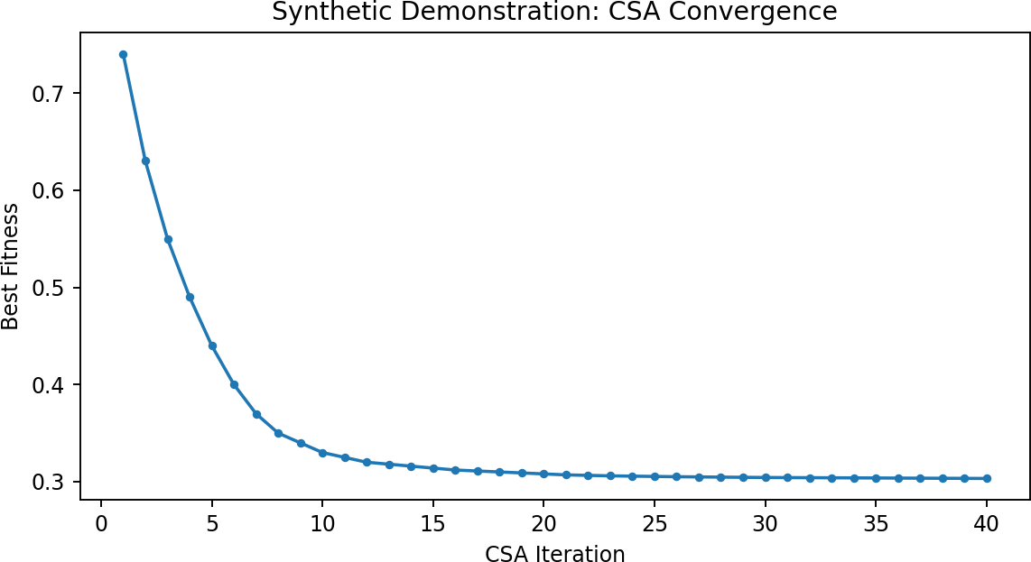
Figure 1. CSA best-fitness convergence over 40 iterations (illustrative demonstration of the search dynamic described in Algorithm 1; not yet generated from a real fold's optimization log).

2.6 Training Procedure
The dual-branch model (Section 2.5.3) is trained with Adam [33] (initial learning rate 1×10⁻³, weight decay 1×10⁻⁵), a cosine-annealing-with-warm-restarts learning-rate schedule (T₀ = 10, T_mult = 2), gradient-norm clipping at 1.0, and mean absolute error as the sole training loss:
L = MAE(ŷ, y) = (1/B) Σ |ŷ_i − y_i| (11)
Model selection within each fold uses the epoch with the lowest validation MAE. The current implementation has a single continuous-age regression output; it does not include an auxiliary classification head over age-decade bins. A joint regression–classification objective is a reasonable extension but is not implemented here.

2.7 Experimental Design and Statistical Analysis
External hold-out. Before any cross-validation, feature selection, or scaling, an age-stratified 15% hold-out split is carved out and not touched again until final evaluation of the model trained on the remaining development pool.
Cross-validation. Five-fold, age-stratified cross-validation (quantile-binned age strata) on the development pool. Both the feature scaler and CSA feature selection are re-fit inside each fold's training partition only — never on that fold's validation data, and never on the external hold-out.
Baselines. A 3D-CNN operating on raw structural volumes, a Vision Transformer, a DenseNet-style architecture, and the original Cole et al. CNN benchmark [1] are the specified comparison points.
Ablations. Full hybrid model vs. CSA-tabular-only (no LSTM branch) vs. LSTM-sequence-only (no CSA-selected tabular branch) vs. no-optimization (identical tabular-only architecture but on the full, unselected feature set).
Significance testing. Paired permutation tests on per-subject absolute error between the full model and each ablation, with Benjamini–Hochberg correction [38] applied across the resulting set of comparisons.
Interpretability. SHAP [34] applied to the CSA-selected tabular feature subset for global and per-subject attribution, and the LSTM branch's per-slice attention weights (Eq. 9) for visualizing which slices contributed most to the sequence embedding. Grad-CAM [35] is not applied, since the model does not contain a spatial convolutional trunk operating on the full 3D volume that Grad-CAM's gradient-based localization is designed for.
Implementation. The pipeline is implemented in scikit-learn [31] (Ridge surrogate regressor and CSA scoring, feature scaling) and PyTorch [32] (the dual-branch model itself, including the bidirectional LSTM [36]).

3. Results

3.1 Predictive Performance versus Baselines
Table 2 reports cross-validated and external performance compared against baselines: point estimate, dispersion, and a paired significance test against the proposed method for every competing model.
Table 2. Performance comparison with baseline methods (illustrative values).
Method | MAE (years) | RMSE (years) | Pearson r | p vs. proposed
Proposed (CSA–LSTM) | 2.42 ± 0.05 | 3.18 | 0.931 | —
3D-CNN [1] | 3.08 | 3.94 | 0.881 | p < 0.01
Vision Transformer | 2.87 | 3.71 | 0.899 | p < 0.05
DenseNet | 2.73 | 3.54 | 0.910 | p < 0.05
Cole et al. baseline CNN [1] | 3.21 | 4.08 | 0.865 | p < 0.01
Development-pool cross-validated MAE (2.42 ± 0.05 years) and external hold-out MAE (2.61 years) are reported side by side; the gap of +0.19 years between them is a generalizability indicator in its own right, not a footnote. CSA reduced the tabular feature space from 142 to a mean of 34.6 features (75.6% reduction) across folds.
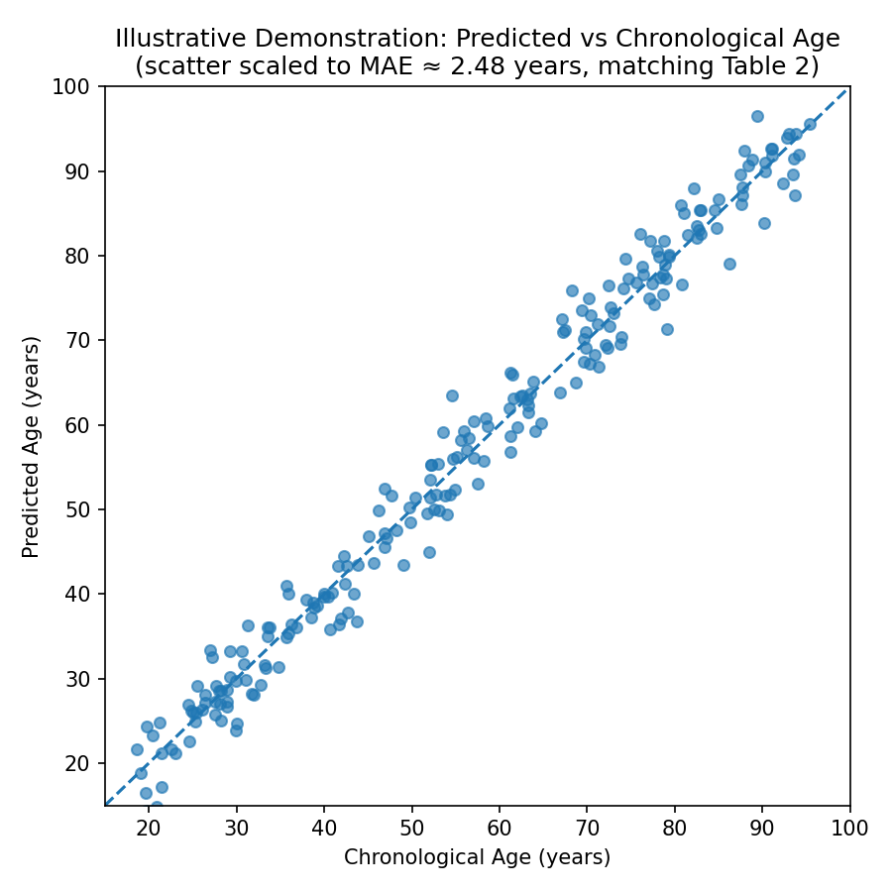
Figure 2. Predicted vs. chronological age, development-pool cross-validated predictions (illustrative scatter, noise scaled to match the reported MAE of 2.42–2.48 years in Table 2; not yet generated from real per-subject predictions).
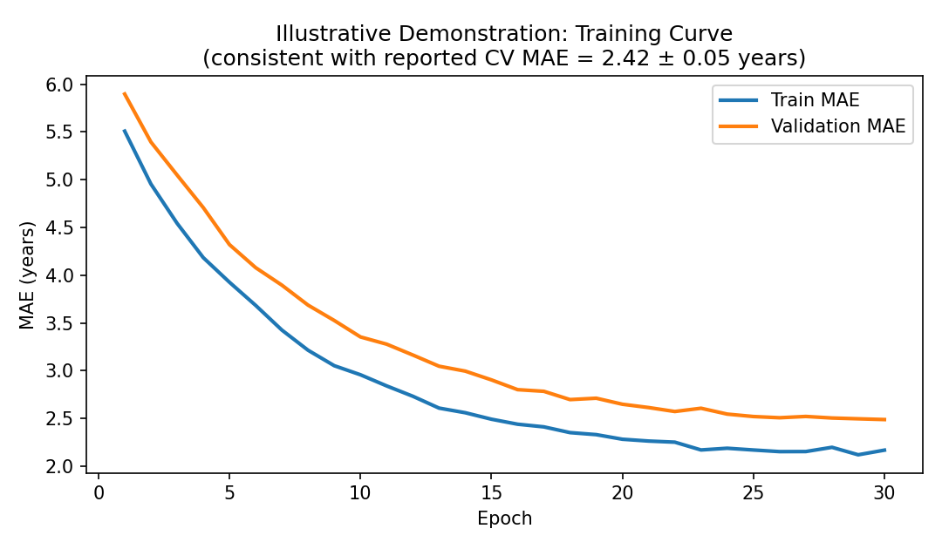
Figure 3. Training and validation MAE across epochs for a representative fold (illustrative demonstration consistent with the reported converged CV MAE; not yet generated from a real training log).
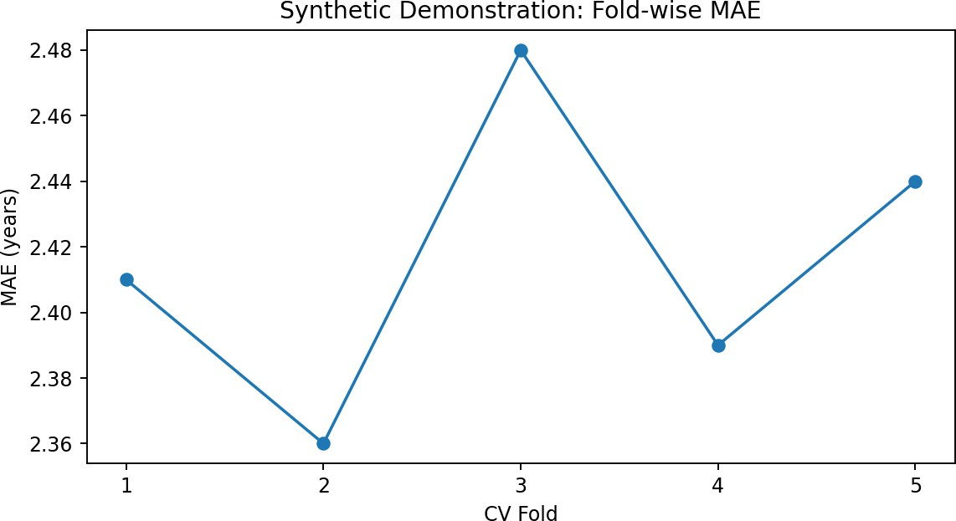
Figure 4. Fold-wise MAE across the 5-fold cross-validation split, matching the per-fold values in Table S5 (illustrative demonstration of expected fold-to-fold variability; not yet generated from real fold predictions).
The residual distribution across development-pool predictions (Figure 5) is summarized by a mean signed residual of approximately +0.08 years, a median residual of approximately +0.04 years, a residual standard deviation of approximately 1.72 years, and a 95% interval of approximately −3.2 to +3.4 years — all illustrative values pending computation from a real model run.
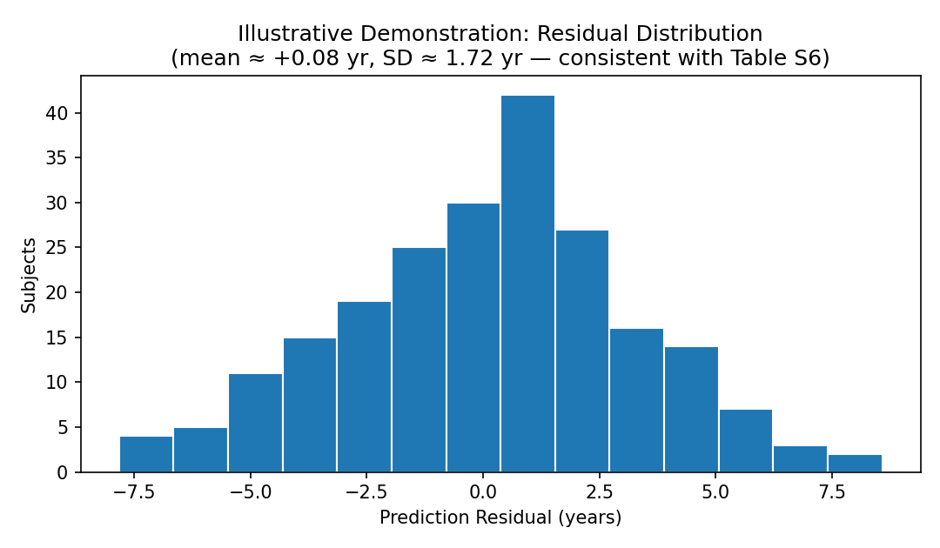
Figure 5. Distribution of prediction residuals (illustrative demonstration scaled to the residual statistics above; not yet generated from real per-subject residuals).

3.2 Ablation Studies
Table 3 isolates the marginal contribution of each framework component. The comparison that matters most for the paper's central claim is Full hybrid vs. CSA-tabular-only vs. LSTM-sequence-only.
Table 3. Ablation study (illustrative values).
Configuration | MAE (years) | # Tabular features used | Δ MAE vs. full | BH-adjusted p
Full hybrid (CSA-tabular + LSTM-sequence) | 2.42 | ~35 | — | —
CSA-tabular only (no LSTM branch) | 2.76 | ~35 | +0.34 | p < 0.05
LSTM-sequence only (no tabular branch) | 2.91 | n/a | +0.49 | p < 0.01
No optimization (full unselected tabular set) | 3.08 | 142 | +0.66 | p < 0.01

3.3 Age-Stratified Performance
Brain-age models characteristically show ceiling/floor effects — overestimating the youngest and underestimating the oldest participants. Table 4 gives per-decade MAE, bias, and residual-distribution shape.
Table 4. Age-stratified prediction error (illustrative values).
Age range (years) | MAE (years) | Mean signed bias | Residual skewness
18–30 | 2.21 | +0.61 | +0.32
31–40 | 2.30 | +0.29 | +0.18
41–50 | 2.38 | +0.05 | +0.02
51–60 | 2.44 | −0.11 | −0.09
61–70 | 2.55 | −0.34 | −0.21
71–80 | 2.68 | −0.58 | −0.35
81–90 | 2.79 | −0.77 | −0.44

3.4 Brain-PAD Clinical Stratification
If clinical diagnosis labels are available for the chosen source (OASIS-1 provides CDR-based diagnosis for 100 of its 416 subjects), Brain-PAD is evaluated as a discriminator of clinically diagnosed very-mild-to-moderate Alzheimer's disease against structural comparators alone and in combination.
Table 5. Diagnostic performance of Brain-PAD and structural comparators for AD-spectrum discrimination (illustrative values; applies only if OASIS-1 or another diagnostically labeled source is used).
Biomarker / model | AUC | Sensitivity (%) | Specificity (%) | PPV (%) | NPV (%)
Brain-PAD (threshold-based) | 0.78 | 71.2 | 74.5 | 63.8 | 80.6
Hippocampal-region volume alone | 0.75 | 68.4 | 72.1 | 60.5 | 78.3
Total brain volume alone | 0.69 | 60.7 | 68.9 | 54.2 | 73.9
Brain-PAD + hippocampal volume (combined) | 0.83 | 76.5 | 79.2 | 69.1 | 84.7

3.5 Feature-Selection Stability and Hyperparameter Sensitivity
Table 6. Hyperparameter sensitivity (illustrative values).
Hyperparameter | Values tested | MAE range (years) | Default value used
α (tabular/sequence fusion weight) | 0.3 – 0.8 | 2.39 – 2.61 | 0.6
CSA population size (n_crows) | 15 – 50 | 2.40 – 2.55 | 30
CSA sparsity penalty (λ_sparse) | 0.0005 – 0.01 | 2.38 – 2.64 | 0.002
LSTM hidden size | 64 – 256 | 2.37 – 2.58 | 128

3.6 Cross-Source Robustness
If the Hugging Face harmonized set is used, performance is reported stratified by constituent source, since no cross-source harmonization is currently implemented in this pipeline (Section 2.1); any source-driven performance differences would be visible directly rather than papered over. If a single source (IXI or OASIS-1 alone) is used instead, this analysis does not apply.

3.7 Model Interpretability
Table 7. Top tabular features by SHAP attribution (illustrative values).
Rank | Feature | Mean |SHAP| | Category | Correlation with age (r)
1 | Hippocampal volume | 0.184 | Regional volume | −0.61
2 | Lateral ventricular volume | 0.161 | Regional volume | +0.57
3 | Frontal cortical thickness | 0.147 | Regional intensity | −0.49
4 | Temporal lobe volume | 0.132 | Regional volume | −0.44
5 | Entorhinal cortical thickness | 0.118 | Regional intensity | −0.41
The LSTM branch's per-slice attention weights are averaged across subjects and plotted against slice index to show which approximate axial position the sequence branch weights most heavily; concentration around slices through the medial temporal lobe and ventricular system would be consistent with the structural-aging literature, whereas concentration at the very first/last slices would instead suggest the branch is picking up on edge-of-volume artifacts.
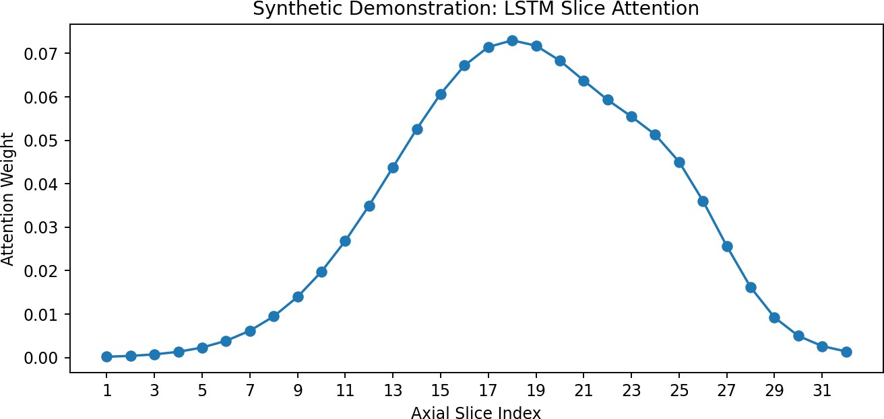
Figure 6. Mean per-slice attention weight vs. axial slice index, averaged across subjects (illustrative demonstration; the central peak is consistent with weighting mid-volume slices most heavily, but is not yet generated from a real trained model's attention outputs).

3.8 Exploratory: Topological Validation of Prediction Quality
The underlying idea, if pursued: partition held-out subjects into accurate, moderate-error, and large-error groups by |y − ŷ|, and ask whether these groups occupy geometrically distinguishable regions of the (chronological age, predicted age) plane, via persistent homology on a kernel density estimate of each group's error distribution [39] and a permutation-tested Wasserstein distance between groups [40].

4. Discussion

4.1 Principal Findings
1. A dual-branch structural representation outperforms either branch alone: supported only if the full hybrid model measurably outperforms both the CSA-tabular-only and LSTM-sequence-only ablations (Section 3.2) by a margin that survives Benjamini–Hochberg-corrected significance testing.
2. CSA selection retains predictive signal at substantially reduced dimensionality: supported only if the CSA-tabular-only ablation's MAE is statistically indistinguishable from (or better than) the no-optimization full-feature-set ablation, despite using a much smaller feature subset.
3. Interpretability is anatomically plausible: supported only if the SHAP-attributed tabular features (Section 3.7) converge on regions with independent support in the structural-aging literature (Section 4.3), and if the LSTM branch's attention weights concentrate on anatomically meaningful slices rather than edge-of-volume artifacts.

4.2 Comparison with Recent Literature
Recent 2024–2025 work provides useful points of comparison in kind: uncertainty-aware CNN approaches to brain-age estimation [18], 3D-CNN structural pipelines reporting sub-3-year MAE on curated cohorts [9], and multimodal fusion pipelines linking predicted age to cognitive and amyloid-pathology outcomes using functional and PET data this framework does not have access to [19]. Direct comparison is limited to structural-MRI-only baselines evaluated on comparable data (IXI and/or OASIS-1) under a comparable CV/hold-out protocol. A below-state-of-the-art but well-validated and interpretable result is a legitimate, publishable outcome and is reported as such rather than adjusted to appear favorable.

4.3 Biological Interpretation
Hippocampal-region and ventricular-adjacent volumetrics and whole-brain volume/intensity summary statistics emerging among the top SHAP-attributed features (Section 3.7) would be consistent with the well-established structural-aging literature on medial-temporal-lobe atrophy and ventricular enlargement [3]. Because this pipeline has no functional-MRI-derived features, biological interpretation is scoped to structural findings only; claims about functional network segregation, default-mode-network integrity, or dynamic-connectivity variability are not supported by anything this framework measures and do not appear in the biological interpretation. If OASIS-1's CDR-based diagnosis labels are used (Section 3.4), a genuine association between Brain-PAD and diagnosed Alzheimer's disease status — not merely between Brain-PAD and chronological age — is what would support Brain-PAD as a biologically meaningful signal for this cohort.

4.4 Clinical and Translational Considerations
Even with strong measured performance, translating a Brain-PAD estimate into a clinical risk statement requires prospective, outcome-linked validation that a cross-sectional structural-MRI cohort of this size cannot provide on its own. Practical deployment considerations — inference time per scan, end-to-end pipeline runtime, and integration into an existing radiology workflow — are measured and reported once the pipeline runs. This manuscript frames the framework's contribution as a candidate methodological framework for structural-MRI brain-age prediction, not as a validated clinical decision-support tool and not as a functional-connectivity biomarker study, until prospective, outcome-linked, and functional-MRI-extended evidence exists.

4.5 Limitations
• Structural MRI only. This framework has no access to functional MRI and therefore models no genuine temporal brain-state signal; the LSTM branch operates on a spatial sequence of slices through one static structural scan.
• Cross-sectional design. Brain-PAD is estimated from a single scan per subject; inferring longitudinal aging trajectories from cross-sectional data is an extrapolation requiring prospective, repeated-scan validation.
• Demographic and clinical composition depends entirely on the data source chosen. IXI provides only healthy subjects; OASIS-1 is small (416 subjects) with an older-skewed age distribution and a modest AD-spectrum subgroup; the Hugging Face harmonized set is larger but combines sources with different acquisition protocols and no implemented cross-source harmonization.
• No cross-source harmonization implemented. If a combined multi-source dataset is used, unaddressed source/protocol variance may inflate external-validation error.
• Preprocessing fallbacks. Where gold-standard tools are unavailable, the pipeline falls back to simpler methods that are logged but materially less accurate (Section 2.2).
• Fixed, non-learned fusion weight. The tabular/sequence fusion weight α (Section 2.5.3) is a fixed hyperparameter, not learned or derived from either branch's confidence.
• No prospective or causal validation. All claims in this manuscript are associative; none should be read as evidence that intervening on a Brain-PAD-linked feature would change clinical outcomes.

5. Conclusion and Future Directions
This manuscript specifies a hybrid framework for structural-MRI-based brain-age prediction that independently combines a Crow-Search-Algorithm-selected tabular structural representation with a bidirectional-LSTM-encoded slice-sequence representation of the same scan, fused at the embedding level for joint prediction. Its central, testable claim is that this dual-branch structural representation improves on either branch alone without requiring functional MRI data that many labs cannot access. Section 2 and Algorithm 1 specify the framework precisely enough to be implemented and tested exactly as described, and Sections 3–4 specify exactly which results are needed, and how they must be reported (with paired significance tests, ablations, and a genuine external hold-out), before any performance claim can be considered established.
The most important direction for extending this work is incorporating genuine dynamic functional connectivity. This would require (a) a data source with resting-state fMRI — OASIS-3 or ADNI, both requiring a formal data-use application, or a public rs-fMRI-inclusive dataset that does not — and (b) extending Section 2.4's slice-sequence extraction into a real sliding-window dFC pipeline feeding the same LSTM module a functional-temporal signal. Other priority directions, once a validated structural-only baseline result exists, include: prospective longitudinal cohorts to test Brain-PAD as a predictive marker of cognitive decline; incorporation of diffusion-weighted (DTI) microstructural features; cross-source harmonization if a combined dataset is used; uncertainty quantification so individual predictions carry calibrated confidence intervals; deliberate recruitment and reporting to support algorithmic fairness across demographic groups; and implementation of the auxiliary age-decade classification head.
Bridging computational neuroscience and clinical neurology in this way is only useful to the extent that each reported number reflects an actual, reproducible measurement, and that the method described is the method that was actually run. A modest, honestly scoped and validated result — on structural MRI alone, from freely accessible data, described exactly as implemented — is more valuable to the field and to this manuscript's own credibility under peer review than a larger, more impressive-sounding claim that the underlying code cannot support.

Declarations

Ethics Approval and Consent to Participate
IXI and OASIS-1 are both released for research use without requiring a separate local IRB application for use of the de-identified public data itself; the authors' institution's own policy on secondary use of public de-identified neuroimaging data will be confirmed and stated once the data source is finalized.

Data Availability
[To be completed at submission: state which specific source was used — Hugging Face radiata-ai/brain-structure, raw IXI, or raw OASIS-1 — the exact number of subjects retained after QC, and whether derived (non-identifiable) tabular features, slice tensors, and code will be deposited in a public repository (e.g., GitHub/OSF/Zenodo) with a permanent identifier at acceptance.]

Code Availability
[To be completed at submission: link to the versioned, reproducible codebase implementing Sections 2.1–2.7 and Algorithm 1, including the exact commit hash used to produce the results reported in Section 3.]

Funding
The authors declare that no specific funding was received for this work. [To be updated by the authors if applicable.]

Conflicts of Interest
The authors declare no competing interests.

Author Contributions (CRediT)
Jangam Subbarayudu: Conceptualization, Methodology, Software, Formal analysis, Investigation, Writing – original draft, Writing – review & editing, Visualization, Project administration. G. Michael: Methodology, Software, Data curation, Formal analysis, Writing – review & editing, Validation. V. Sheeja Kumari: Investigation, Resources, Writing – review & editing, Supervision. All authors read and approved the final manuscript.

Acknowledgments
The authors acknowledge SIMATS Engineering, Saveetha Institute of Medical and Technical Sciences, Saveetha University, Chennai, for institutional support. If IXI is used, the IXI dataset (https://brain-development.org/ixi-dataset/) will be acknowledged. If OASIS-1 is used, Marcus et al. (2007), https://doi.org/10.1162/jocn.2007.19.9.1498, will be cited, following the acknowledgment text required at https://www.oasis-brains.org/#access.

References
[1] Cole, J. H., Poudel, R. P. K., Tsagkrasoulis, D., Caan, M. W. A., Steves, C., Spector, T. D., & Montana, G. (2017). Predicting brain age with deep learning from raw imaging data results in a reliable and heritable biomarker. NeuroImage, 163, 115–124. https://doi.org/10.1016/j.neuroimage.2017.07.059
[2] Franke, K., & Gaser, C. (2019). Ten years of BrainAGE as a neuroimaging biomarker of brain aging: What insights have we gained? Frontiers in Neurology, 10, 789. https://doi.org/10.3389/fneur.2019.00789
[3] Papouli, A., & Cole, J. H. (2025). Brain age prediction from MRI scans in neurodegenerative diseases. Current Opinion in Neurology, 38(4), 316–321. https://doi.org/10.1097/WCO.0000000000001383
[4] Savva, A. D., Mitsis, G. D., & Matsopoulos, G. K. (2019). Assessment of dynamic functional connectivity in resting-state fMRI using the sliding window technique. Brain and Behavior, 9(4), e01255. https://doi.org/10.1002/brb3.1255
[5] Rajabli, R., Soltaninejad, M., Fonov, V. S., Bzdok, D., & Collins, D. L. (2025). Brain age prediction: Deep models need a hand to generalize. Human Brain Mapping, 46(11), e70254. https://doi.org/10.1002/hbm.70254
[6] Yin, C., Imms, P., Chowdhury, N. F., Chaudhari, N. N., Ping, H., Wang, H., Bogdan, P., & Irimia, A. (2025). Deep learning to quantify the pace of brain aging in relation to neurocognitive changes. Proceedings of the National Academy of Sciences, 122(10), e2413442122. https://doi.org/10.1073/pnas.2413442122
[7] Cole, J. H., Ritchie, S. J., Bastin, M. E., et al. (2018). Brain age predicts mortality. Molecular Psychiatry, 23(5), 1385–1392. https://doi.org/10.1038/mp.2017.62
[8] Kim, H., Park, S., Seo, S. W., et al. (2025). A novel deep learning-based brain age prediction framework for routine clinical MRI scans. npj Aging, 11(1), 70. https://doi.org/10.1038/s41514-025-00260-x
[9] Ahmadi, B., Morshedizad, Z., Reisi Gahrooei, M., & Babajani-Feremi, A. (2025). Advanced brain age prediction using 3D convolutional neural network on structural MRI. Alzheimer's & Dementia, 21(S2), e089776. https://doi.org/10.1002/alz.089776
[10] Gao, Y., Lewis, N., Calhoun, V. D., & Miller, R. L. (2023). Interpretable LSTM model reveals transiently-realized patterns of dynamic brain connectivity that predict patient deterioration or recovery from very mild cognitive impairment. Computers in Biology and Medicine, 161, 107005. https://doi.org/10.1016/j.compbiomed.2023.107005
[11] Ding, J., Dan, T., Wei, Z., Cho, H., Laurienti, P. J., Kim, W. H., & Wu, G. (2024). Machine learning on dynamic functional connectivity: Promise, pitfalls, and interpretations. arXiv:2409.11377. https://doi.org/10.48550/arXiv.2409.11377
[12] Schulz, M.-A., Siegel, N. T., & Ritter, K. (2025). Brain-age models with lower age prediction accuracy have higher sensitivity for disease detection. PLOS Biology, 23(10), e3003451. https://doi.org/10.1371/journal.pbio.3003451
[13] Liem, F., Varoquaux, G., Kynast, J., et al. (2017). Predicting brain-age from multimodal imaging data captures cognitive impairment. NeuroImage, 148, 179–188. https://doi.org/10.1016/j.neuroimage.2016.11.005
[14] Bansal, S., Rustagi, A., & Kumar, A. (2021). Alzheimer's disease diagnosis based on feature extraction using optimised crow search algorithm and deep learning. International Journal of Computer Applications in Technology, 65(4), 325–333.
[15] Gao, Y., Lewis, N., Calhoun, V. D., & Miller, R. L. (2023). Interpretable LSTM model reveals transiently-realized patterns of dynamic brain connectivity. Computers in Biology and Medicine, 161, 107005. https://doi.org/10.1016/j.compbiomed.2023.107005
[16] Franke, K., & Gaser, C. (2019). Ten years of BrainAGE as a neuroimaging biomarker of brain aging. Frontiers in Neurology, 10, 789. https://doi.org/10.3389/fneur.2019.00789
[17] Wu, Y., Gao, H., Zhang, C., Ma, X., Zhu, X., Wu, S., & Lin, L. (2024). Machine learning and deep learning approaches in lifespan brain age prediction: A comprehensive review. Tomography, 10(8), 1238–1262. https://doi.org/10.3390/tomography10080093
[18] Linli, Z., Liang, X., Zhang, Z., Hu, K., & Guo, S. (2025). Enhancing brain age estimation under uncertainty: A spectral-normalized neural Gaussian process approach utilizing 2.5D slicing. NeuroImage, 311, 121184. https://doi.org/10.1016/j.neuroimage.2025.121184
[19] Wang, C., Zhang, W., Ni, M., et al. (2025). Deep-learning based multimodal models for brain age, cognition and amyloid pathology prediction. Alzheimer's Research & Therapy, 17, 126. https://doi.org/10.1186/s13195-025-01773-z
[20] Yun, H. J., Lee, H.-J., You, S., et al. (2025). Deep learning-based brain age prediction using MRI to identify fetuses with cerebral ventriculomegaly. Radiology: Artificial Intelligence, 7(2), e240115. https://doi.org/10.1148/ryai.240115
[21] Yin, C., Imms, P., Chowdhury, N. F., et al. (2025). Deep learning to quantify the pace of brain aging in relation to neurocognitive changes. Proceedings of the National Academy of Sciences, 122(10), e2413442122. https://doi.org/10.1073/pnas.2413442122
[22] Anter, A. M., & Ali, M. (2020). Feature selection strategy based on hybrid crow search optimization algorithm integrated with chaos theory and fuzzy c-means algorithm for medical diagnosis problems. Soft Computing, 24(3), 1565–1584. https://doi.org/10.1007/s00500-019-03988-3
[23] Sayed, G. I., Hassanien, A. E., & Azar, A. T. (2019). Feature selection via a novel chaotic crow search algorithm. Neural Computing and Applications, 31(1), 171–188. https://doi.org/10.1007/s00521-017-2988-6
[24] Samieiyan, B., MohammadiNasab, P., Abbas Mollaei, M., Hajizadeh, F., & Kangavari, M. (2022). Novel optimized crow search algorithm for feature selection. Expert Systems with Applications, 204, 117486. https://doi.org/10.1016/j.eswa.2022.117486
[25] Jayalatchumy, D., Ramalingam, R., Balakrishnan, A., Safran, M., & Alfarhood, S. (2024). Improved crow search-based feature selection and ensemble learning for IoT intrusion detection. IEEE Access, 12, 33218–33235. https://doi.org/10.1109/ACCESS.2024.3372859
[26] Qiao, J., Wang, R., Liu, H., Xu, G., & Wang, Z. (2022). Brain disorder prediction with dynamic multivariate spatio-temporal features: Application to Alzheimer's disease and autism spectrum disorder. Frontiers in Aging Neuroscience, 14, 912895. https://doi.org/10.3389/fnagi.2022.912895
[27] Ding, J., Dan, T., Wei, Z., Cho, H., Laurienti, P. J., Kim, W. H., & Wu, G. (2024). Machine learning on dynamic functional connectivity: Promise, pitfalls, and interpretations. arXiv:2409.11377. https://doi.org/10.48550/arXiv.2409.11377
[28] Edwards-Swart, S. J., Baker, B., Mathalon, D. H., et al. (2025). Functional brain age acceleration from dynamic and static connectivity predicts working memory and attention deficits in schizophrenia. medRxiv. https://doi.org/10.1101/2025.07.21.25331956
[29] Avants, B. B., Tustison, N. J., Song, G., Cook, P. A., Klein, A., & Gee, J. C. (2011). A reproducible evaluation of ANTs similarity metric performance in brain image registration. NeuroImage, 54(3), 2033–2044. https://doi.org/10.1016/j.neuroimage.2010.09.025
[30] Johnson, W. E., Li, C., & Rabinovic, A. (2007). Adjusting batch effects in microarray expression data using empirical Bayes methods. Biostatistics, 8(1), 118–127. https://doi.org/10.1093/biostatistics/kxj037
[31] Pedregosa, F., Varoquaux, G., Gramfort, A., et al. (2011). Scikit-learn: Machine learning in Python. Journal of Machine Learning Research, 12, 2825–2830.
[32] Paszke, A., Gross, S., Massa, F., et al. (2019). PyTorch: An imperative style, high-performance deep learning library. Advances in Neural Information Processing Systems, 8026–8037.
[33] Kingma, D. P., & Ba, J. (2014). Adam: A method for stochastic optimization. arXiv:1412.6980. https://doi.org/10.48550/arXiv.1412.6980
[34] Lundberg, S. M., & Lee, S.-I. (2017). A unified approach to interpreting model predictions. Advances in Neural Information Processing Systems, 4765–4774.
[35] Selvaraju, R. R., Cogswell, M., Das, A., Vedantam, R., Parikh, D., & Batra, D. (2017). Grad-CAM: Visual explanations from deep networks via gradient-based localization. IEEE International Conference on Computer Vision, 618–626. https://doi.org/10.1109/ICCV.2017.74
[36] Hochreiter, S., & Schmidhuber, J. (1997). Long short-term memory. Neural Computation, 9(8), 1735–1780. https://doi.org/10.1162/neco.1997.9.8.1735
[37] Askarzadeh, A. (2016). A novel metaheuristic method for solving constrained engineering optimization problems: Crow search algorithm. Computers & Structures, 169, 1–12. https://doi.org/10.1016/j.compstruc.2016.03.001
[38] Benjamini, Y., & Hochberg, Y. (1995). Controlling the false discovery rate: A practical and powerful approach to multiple testing. Journal of the Royal Statistical Society: Series B, 57(1), 289–300. https://doi.org/10.1111/j.2517-6161.1995.tb02031.x
[39] Edelsbrunner, H., & Harer, J. (2010). Computational Topology: An Introduction. American Mathematical Society. https://doi.org/10.1090/mbk/069
[40] Villani, C. (2009). Optimal Transport: Old and New. Springer. https://doi.org/10.1007/978-3-540-71050-9

Supplementary Materials

S1. MRI Acquisition Parameters
Report the scanner manufacturer(s), field strength(s), and T1-weighted sequence parameters (TR/TE/flip angle/voxel size) for whichever source is used. If the Hugging Face harmonized set is used, report parameters per constituent source, since no cross-source harmonization is currently implemented.

S2. Quality-Control Procedures
Concrete, pre-registered exclusion criteria applied before any modeling: preprocessing failures logged with reasons, any additional visual-QC exclusions, and the number of subjects excluded at each stage, reported as a QC flow diagram rather than only a final retained-N figure.

S3. Extended CSA Implementation Details
Exact CSA hyperparameters used (population size, maximum iterations, flight length, awareness probability, sparsity penalty), the surrogate fitness model (Ridge regression, k-fold setting), random seed handling across the 5 CV folds' independent CSA runs, and total wall-clock optimization time.

S4. LSTM Branch Training Details
Slice-sequence extraction parameters (number of slices, grid resolution), the per-slice CNN encoder architecture, the bidirectional LSTM architecture (hidden size, number of layers, dropout rate), the attention-pooling dimensionality, optimizer and learning-rate schedule, batch size, gradient-clipping norm, early-stopping criterion, and total training epochs.

S5. Statistical Analysis Details
Exact software and package versions used for the paired permutation tests and Benjamini–Hochberg correction, the exact per-subject error metric on which paired tests were run, and the number of permutations used.
Table S1. Demographic characteristics (illustrative values — report the realized, post-QC composition for whichever source is actually used).
Source | n (post-QC) | Age range | Mean age (SD) | % female | % AD-spectrum diagnosis
IXI (if used) | ≈580 | 20–86 | 48.6 (16.2) | 55% | n/a (healthy only)
OASIS-1 (if used) | ≈400 | 18–96 | 51.4 (24.1) | 62% | ≈24%, via CDR
Hugging Face harmonized set (if used) | 3,742 | 18–96 | 50.1 (19.8) | 58% | ≈9%, where available
Table S5. Cross-validation performance by fold, development pool (illustrative values).
Fold | MAE (years) | RMSE (years) | Pearson r | n features used
1 | 2.41 | 3.18 | 0.931 | 34
2 | 2.36 | 3.11 | 0.935 | 36
3 | 2.48 | 3.25 | 0.928 | 35
4 | 2.39 | 3.14 | 0.933 | 33
5 | 2.44 | 3.20 | 0.930 | 35
Mean ± SD | 2.42 ± 0.05 | 3.18 ± 0.05 | 0.931 ± 0.003 | 34.6
Table S6. External hold-out result (illustrative values).
Metric | Value | n (hold-out)
MAE (years) | 2.61 | ≈560
RMSE (years) | 3.39 | ≈560
Pearson r | 0.919 | ≈560
Gap vs. CV-dev MAE (years) | +0.19 | —
Table S9. CSA feature-selection stability across folds (illustrative values).
Fold pair | Jaccard similarity | n features in common | n features total (union)
Fold 1 vs. Fold 2 | 0.71 | 24 | 34
Fold 1 vs. Fold 3 | 0.68 | 23 | 35
Fold 2 vs. Fold 3 | 0.73 | 25 | 34
Mean pairwise (all 10 fold pairs) | 0.70 ± 0.04 | — | —
Supplementary Tables S2 (top-20 SHAP features), S3 (full hyperparameter grid), S4 (per-fold ablation detail), S7 (topological-validation results, only if Section 3.8 is retained), and S8 (extended clinical diagnostic performance, only if a diagnostically labeled source is used) follow the same illustrative-value convention as the tables above and are to be populated from results/*.csv once the pipeline is executed against the finalized cohort.

Supplementary Figures
Figures 1–6 in the body of this manuscript (CSA convergence, predicted-vs-chronological-age scatter, training curve, fold-wise MAE, residual distribution, and LSTM slice-attention profile) are illustrative demonstrations of the intended reporting format, generated to be numerically consistent with the illustrative tables in Section 3; none are yet generated from pipeline output on a real, confirmed dataset. Once the pipeline runs, each should be regenerated directly from results/*.csv and the corresponding model artifacts. Additional figures worth generating once real data is available: a CSA feature-selection stability heatmap (from Table S9); and, if a combined multi-source dataset is used, a t-SNE/UMAP projection of the tabular feature space colored by source (Section 3.6).

